Field lab: Streams and stream erosion
Portland Community College – Southeast Center Edition

© Frank D. Granshaw 2011

In this project you will be surveying a stream on Mt. Tabor Park to determine where erosion is a significant problem. As is common in fieldwork, what you will be doing is broken up into four parts. The first part, office work, is the planning stage. The second part, fieldwork, is where you will collect the data you need to deal with the designated problem. The third, the analysis is where you try to make sense of all the information. And finally, the fourth part or report writing phase, is where you communicate what you found out. For this activity, you will be working in teams to collect data and talk about your analysis, but each of you will be producing your own report.

The study site:

Mt. Tabor is one of 32 possibly 50 small volcanoes located within a 25 kilometer radius of Southeast Center. Most of Mt. Tabor is a city park administered by Portland Parks and Recreation. In addition to forested, lightly developed park areas, three reservoirs (part of Portland’s municipal water supply) are located in the southwest quarter of the park.  Though Mt. Tabor currently has no year round streams, there is a small ravine on the northwest side of the mountain, below the cinder cone that has a seasonal stream. It is this stream that is the focus of this lab. | 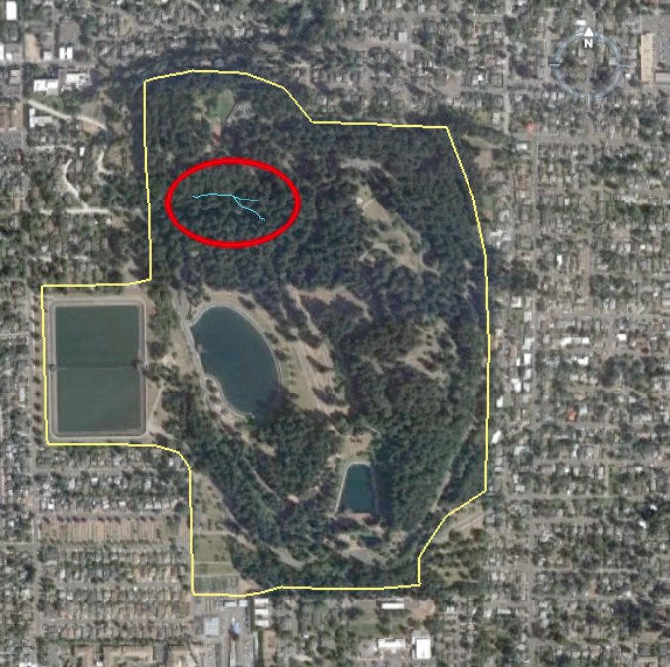  Figure 1 – Aerial photograph of Mt. Tabor Park. The stream we will be investigating in this lab are located in the Northwest corner of the park.
References:

Allen, 1975, Volcanoes of the Portland Area, Oregon: State of Oregon, Department of Geology and Mineral Industries, The ORE-BIN, v.37, no.9, September 1975, p. 147-157
Trimble, D.E.,1963, Geology of Portland, Oregon and adjacent areas; USGS Bulletin 1119, 119 pp.
Walker, Macy, 2000, Mt. Tabor Park Master Plan Report, Portland Parks and Recreation, http://www.mttaborpdx.org/documents/mttaborpark_masterplan.pdf, accessed 6 November 2011

Part 1 – Office work

To begin this phase of the investigation go to the course website and download the Google Earth placemarks provided for this lab. When you open the placemarks folder you will find two items listed, Stream and Valley Profile. The stream placemarks shows two streams (blue lines), the main trunk and a small tributary. The valley profile placemarks show two straight yellow lines that span the upper and lower parts of the ravine.

  - Stream characteristics

Beginning with the streams, determine the rise, run, gradient, and sinuosity of both the main and tributary streams. The following list contains the formulas you will need to use to calculate each characteristic. When you write your report, make sure to show all your calculations for these characteristics along with the units each number is measured in.

- Rise = highest - lowest elevation
Use the cursor / pointer in Google earth to determine the highest and lowest points on both stream sections.
e.g. rise of stream x = 180 m – 165 m = 15 m

- Straight run = the straight-line distance between the beginning and end of each stream section.
To measure these distances use the line option of the ruler tool in Google Earth. Make sure to measure these distances in kilometers.
e.g. straight run of stream x = 25,000 m / 1000 m/km = 25 km

- Stream run = the distance each stream section actually travels from beginning to end.
To measure these distances use the path option of the ruler tool in Google Earth. Measure these distances in kilometers.

- Sinuosity = stream run ÷ straight run
Because sinuosity is a proportion, it has no units.
e.g. sinuosity of stream x = 25 km / 10 km = 2.5

- Gradient = rise (m) ÷ straight run (km)
- Gradient’ = rise (m) ÷ stream run (km)
Both types of gradients will be in meters per kilometer or m/km.
e.g. gradient of stream x = 15 m / 10 km = 1.5 m/km
gradient’ of stream x = 15 m / 25 km = 0.6 m/km

  - Valley Profile

Click either of the valley profiles. This will change your viewing angle so you are looking obliquely at both profiles. In your notes draw a sketch of the two profiles as seen in this view. Make sure to include the stream in your sketch. Label all parts of your sketch and write on it the following information.

- The length of each profile line. This will be the width of the valley at that location.
- The elevation of the highest and lowest points on each profile.

Part 2 – Fieldwork

In this lab we will be surveying the stream with the goal of producing a detailed map of it. To do so we will be measuring key characteristics of the stream channel and surrounding valley, as well as locating principal features (e.g. waterfalls, pools, sediment deposits). To accomplish this you will divide into teams of four. Each team will be responsible for a designated section of the stream. Within your section select five equally spaced sites to gather the following data.

- The width of the stream channel assuming a 10 cm depth.
- The gradient of the stream in this area.
- The maximum slope of the surrounding valley.
- Type of sediment at that location (Mud, sand, gravel, cobbles)

Before collecting this data make a table in your field notes that looks like the one shown in table 1.

Table 1 - Make a copy of this table in your notes. Do not use the one in this handout since it will most likely not have enough room to record all the data you will be collecting.

Team ID ______
Section coordinates
Beginning: Latitude ______________ Longitude ______________
End: Latitude ______________ Longitude ______________

 | Location |  | Stream |  |  | Type of sediment in the channel | Valley  Width  (m)
Site | Latitude | Longitude | Width  (m) | Rise  (m) | Run  (m) | Type of sediment in the channel | Valley  Width  (m)
1
2
3
4
5

After your team has finished gathering data for your section walk the entire length of the stream to get a general sense of what it is like. As you do so locate places where there might be small waterfalls or large pools. Most likely there won’t be water in the stream during our visit so you will have to do a certain amount of informed speculation. Mark these areas on the map provided to you (figure 2) and record the name and latitude and longitude of each area in table form in field notes.

Table 2 – An example of how to record the location of waterfalls and large pools. Make a table like this for your field notes.

Feature # | Feature name | Latitude | Longitude | Comments
1 | Waterfall | 45.51433°N | 122.59661°W | Falls approximately 20 cm high
.
.
Part 3 – Analysis

When we get back to the lab, trade data with the other teams. After you have done so discuss the following questions with your teammates.

- What is the average of all the gradients you measured in your section?
- How does the average gradient of your section compare to the average for each of the other teams? Where are the steepest sections? Where are the sections with lowest gradient?
- Referring to the features map you made in part 2 (what you marked on figure 2) where is stream velocity high in this stream, where is it low? Mark this on the map by color coding areas of the stream (e.g. red for fast and yellow for slow).
- What criteria did you use to answer question 3?
- Based on stream velocity where would you expect erosion to be the highest in this stream? Where would you expect it to be lowest?
- This stream currently empties into a storm drain that eventually empties into the Willamette River. Before the road and houses surrounding the park were built the stream probably continued west through the plains surrounding the mountain. What would the sinuosity and gradient of this stream be like after it had crossed where SE 63rd Ave is now located?

Part 4 – Report writing

Your report should include this handout, your calculations for part 1, every teams data for part 2, and your answers to the questions in part 3. As always, please type your report, use complete sentences, and show all your calculations.
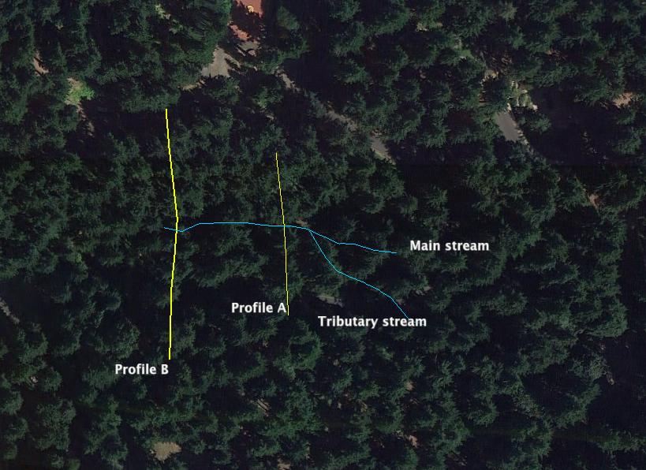

Figure 2 – An aerial photograph of the ravine. Use this figure to record the location of your field data.
Recommendation – Tape a sheet of tracing paper over the map to mark your data locations on.

